QS6: STAR LAWS (Shedding Light on Astronomy) EPISODE VI: Where is the Sun Right Now? It’s Above the Subsolar Point! Name: _____________________________________________
- What is the subsolar point? ___________________________________________________________________
____________________________________________________________________________________________________________________________________________________________________________________
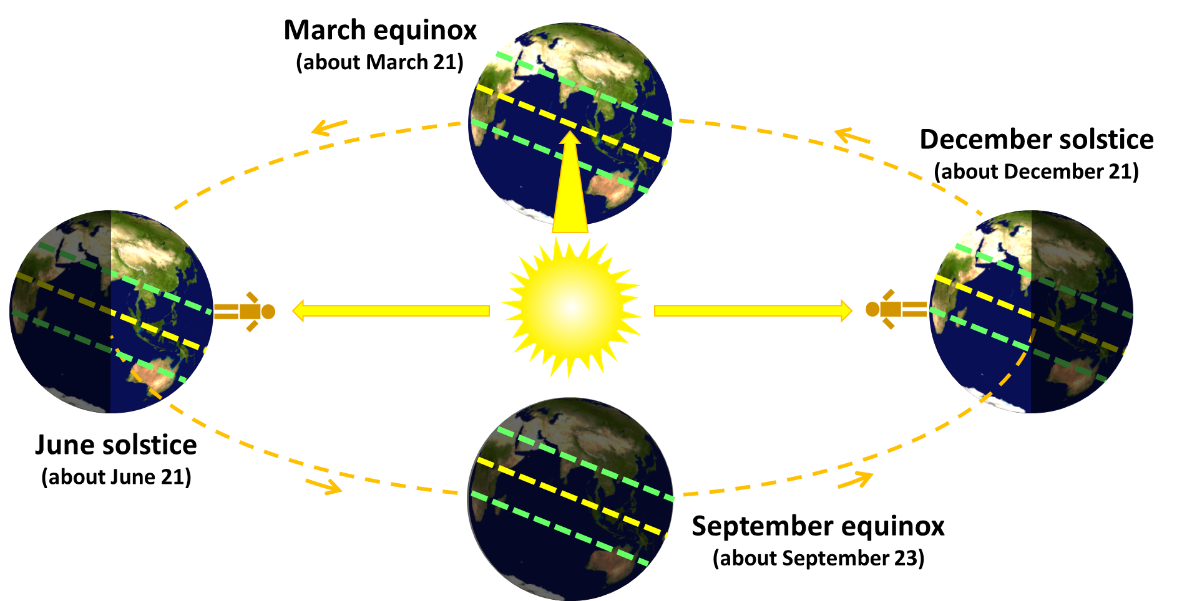
- On the December solstice, the sun is directly above the ____________________________________, which has a latitude of _________°S.
- On the day of the June solstice, the sun is directly above the __________________________________, which has a latitude of _________°N.
- On the March equinox and on the September equinox, the sun is directly over the ____________________, which has a latitude of _________ degrees. Daytime and night time are about _________ hours each.

- Given the information above, it follows that the subsolar point between the December solstice and the March equinox is somewhere between the ___________________________ and the _________________________.
- Use the table of the latitude of the subsolar point at different times of the year to draw a line graph. Each solid vertical line is the start of the month. Connect the dots with a smooth line.
(Technical note: The number of days in each month varies slightly, but the graph shows all the months equally spaced. This is not ideal but is okay for our purposes.) HINT: the latitude of the subsolar point on January 1 is SOUTH of the equator.
Latitude of the Subsolar Point
Date | Latitude
January 1 | 23° South
February 1 | 17° S
March 1 | 7.5° S
March 21 (equinox) | 0°
April 1 | 4.5° N
May 1 | 15° N
June 1 | 22° N
June 21 (solstice) | 23.4° N
July 1 | 23° N
August 1 | 18° N
September 1 | 8° N
Sep 23 (equinox) | 0°
October 1 | 3.5° S
November 1 | 14.5° S
December 1 | 22° S
Dec 21 (solstice) | 23.4° S
Dec 31 | 23° S
Jan Feb Mar Apr May Jun Jul Aug Sep Oct Nov Dec
DATE
Equator
Tropic of Cancer
(23.4° N)
Tropic of Capricorn
(23.4° S)
Equinox Solstice Equinox Solstice
North
South
- Between the December solstice and the June solstice, the subsolar point spirals towards the _________________ (north or south), until it is directly over the _________________________. It then stops moving __________________ (northwards or southwards), and starts moving back towards the ____________________ (north or south) again until the December solstice.
- What does the word equinox mean? ____________________________________________________________
____________________________________________________________________________________________
- What does the word solstice mean? _____________________________________________________________
____________________________________________________________________________________________
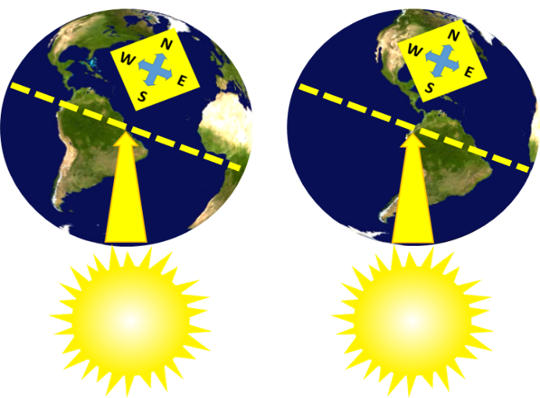
- In Picture 1 on the left, the subsolar point is on the ____________ coast of South America. (east or west)
Picture 1
Picture 2
- About two hours later, the Earth has turned about 30° on its axis and the subsolar point is now on the ____________ coast of South America.
- While the subsolar point moves northwards and southwards over the course of the year, it also sweeps across the Earth daily. Since the Earth is spinning from west to east, the subsolar point is constantly moving from ______________ to ______________.
- Use the timeanddate.com website to find where the subsolar point is right now. To do this, hover over the Sun, Moon, & Space tab and then click Day and Night Map. Scroll down to see the whole map and then scroll down further to Position of the Sun: Subsolar Point to get the co-ordinates of the subsolar point. You do not need to type in your location or to change the time since the website will display the co-ordinates of the subsolar point for the moment that you accessed the web page. (You will, however, need to type in your location for the next question sheet.)
Mark the subsolar point on the map and write (a) the date, (b) your local time right now (not UTC time), and (c) the subsolar point’s latitude and longitude co-ordinates (to the nearest degree).
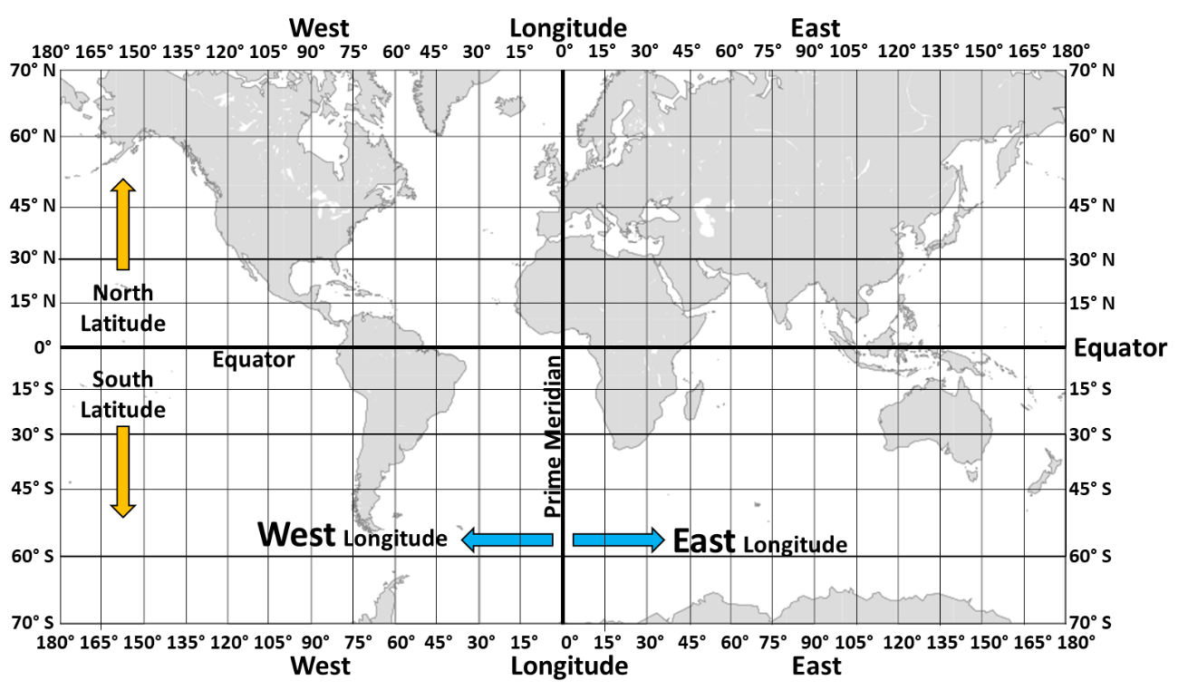
One degree is divided into 60 minutes, so a latitude of, for example, 7.5° can also be written as 7°30’ (7 degrees and 30 minutes). 30’ is half (or 0.5) of a degree.
15 minutes is ¼ (or 0.25) of a degree.
10 minutes is 10/60 of a degree which is 1/6 of a degree (or 0.167°).
Google maps expresses latitude and longitude co-ordinates using decimal co-ordinates (like 7.5°). Decimal notation is more common.
Your Local Time right now (not UTC time): __________ Date: ___________ Latitude: ________ Longitude: ________
- Just under the timeanddate.com map, click the “+6 hours” tab and mark the position of the subsolar point 6 hours from now. Mark the subsolar point on the map and fill in the information below.
Your local time 6 hours from now (not UTC time): ________ Date: _________ Latitude: ________ Longitude: ________

